Air Quality Analysis for the month of October in India
This is an analysis of the Air Quality of India in the month of October and the various reasoning behind the sudden changes in AQI in the major cities of India.
India was home to 11 of the 15 most polluted cities in Central and South Asia in 2021.
In India, if we look at the annual average of PM 2.5, all six metro cities except Chennai saw a rise in air pollution levels last year. Delhi was followed by Kolkata, Mumbai, Hyderabad, Bengaluru and Chennai.
In the month of October, the pollution situation changes drastically across the country, more importantly in the major cities which can be seen in the bar-plots. The AQI(Air Quality Index) increases with a Magnitude of 5% across the country. The Average of AQI increased from 160 on 1st October to 168 on 31st October 2022.The healthy AQI is below 150, so it is clearly above the mark and there are multiple reasons for poor quality of air in our country.
The Population of a State and development stage of a state has an effect on the quality of the air in a state.
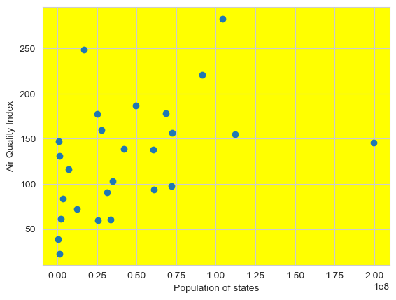
As we can see in this scatterplot that the population is in accordance with the AQI of a state. In the Metro Cities like Delhi, Bangalore, Mumbai etc , the correlation of AQI and population density increases drastically.
We are going to analyse social and economic aspect of the Situation.
Social:
•We can see that the quality of Air has gotten worse in the month of October specially in North India.
•One of the major reasons for the collapse in air quality in North India is stubble burning in India's food bowls Punjab and Haryana.
•Vehicular and industrial emissions that get trapped in the winter fog intensifies the harsh gases in the atmosphere.
•The fireworks for the Diwali and Dusshera celebrations causes the emission of Carbon di-oxide and other harmful gases destroying the environment.
•Also, no Indian city met the World Health Organization’s air quality standards of 5 micrograms per cubic meter. For the fourth consecutive year, Delhi was the world’s most polluted capital.

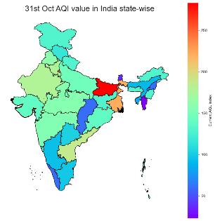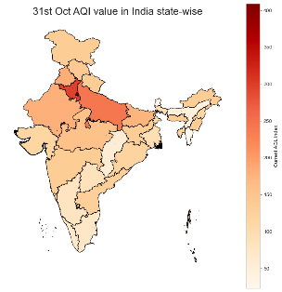
Economic:
- India is a services-driven economy and it has some of world’s most air-polluted cities at a relatively early stage of its manufacturing evolution. As India expands its manufacturing, the problem will only rise exponentially. The reason big cities are on the top of AQI index is the abuse of resources in the economy which has led to more destruction of natural resources like reduction in the levels of oxygen.
- This is also apparent because we can see that in states like Assam have much lower AQI because of lack of modernization and industrialization.
- Besides endangering health and shortening lifespan, air pollution adversely affects economic productivity.
- The Sustainable Development Goals (SDGs) call for reduction of the burden of deaths and diseases from air pollution.
- There has been sudden drop in air quality in Bihar by the end on October and the reasoning behind it is that the AQI in the State has deteriorated owing to the weather transition as the temperature has already started dipping ahead of the winter season while massive vehicular rush due to the festive season has also added to the woes.

Let us look at the Current Air Quality Index of states in India on October:
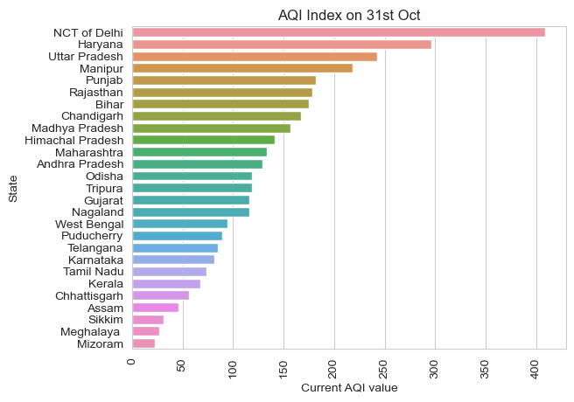
The AQI of more than 150 is considered non desirable and a lot of the Indian states are past that threshold, in fact UP, Delhi, Haryana and Punjab are in severe AQI zone of more than 200 and can cause serious diseases.
Whereas in states like Assam, Sikkim, Meghalaya, Mizoram etc., the Air quality is most desirable main reason being less commercialization and industrialization.

